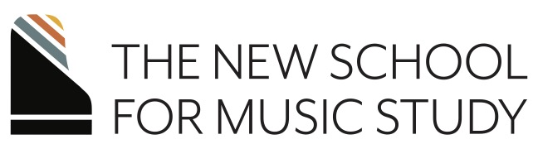

Faculty Favorites
featuring the faculty of The New School for Music Study
February 4, 2024 2:30 p.m.
A partnership with Nassau Presbyterian Church

Sonata in B-flat Major, K. 333, Mvt. I W.A. Mozart (1756-1791)
Jason Gallagher
Un Reve En Mer, Op. 28 Teresa Carreño (1853-1917)
Amy Glennon

Passacaglia Aaron Copland (1900-1990)

Marvin Blickenstaff
Rio Daniel Cueto (b. 1986)
Embraceable You (etude) Gershwin, arr. Wild
Gonzalo Aguilar
Toccata in C Major, Op. 7 Robert Schumann (1810-1856)
Allegro in B Minor, op. 8
Derek Hartman
El Albaicín Isaac Albéniz (b. 1860-1909)
Alexa Stier

Full performer bios may be found at nsmspiano.org

Thank you to
  - NSMS faculty performers: Gonzalo Aguilar, Marvin Blickenstaff, Jason Gallagher, Amy Glennon, Derek Hartman, and Alexa Stier

  - Nassau Presbyterian Church for their partnership in sponsoring this recital, and specifically Noel Werner

  - Staff of NSMS and The Frances Clark Center

Upcoming Events:
April 22, 2024: Silent Film Celebration, AMC Marketfair 10

For information about lessons, classes, and upcoming events, visit us at nsmspiano.org

As a registered non-profit organization, we always welcome your continued support of our mission and programs. Donations gladly accepted. We invite your support via our website or the QR code below.

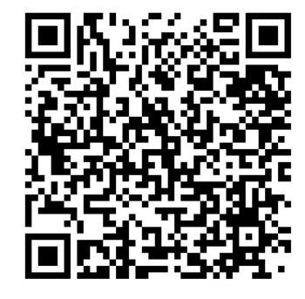

The Frances Clark Center for Keyboard Pedagogy, a not-for-profit educational institution (501c3) located in Kingston, NJ, serves pianists and teachers through its divisions: The National Conference on Keyboard Pedagogy, Piano Magazine, Teacher Education, and the New School for Music Study. www.nsmspiano.org

