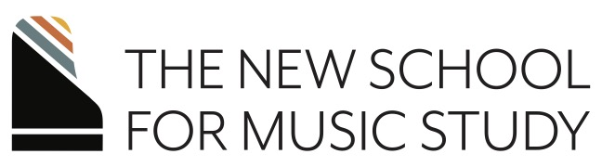

Faculty Favorites
featuring the faculty of The New School for Music Study
February 8, 2024 , 1:00 p.m.
A partnership with Stonebridge at Montgomery

Sonata in B-flat Major, K. 333, Mvt. I W.A. Mozart (1756-1791)
Jason Gallagher

Rio Daniel Cueto (b. 1986)
Embraceable You (etude) Gershwin, arr. Wild
Gonzalo Aguilar

Un Reve En Mer, Op. 28 Teresa Carreño (1853-1917)
Amy Glennon

Three Mazurkas, Op. 59 Frederic Chopin (1810-1849)
Derek Hartman
Sonata in G minor, Op. 22, No. 2 Robert Schumann (b. 1810-1856)
- So rash wie möglich
- Andantion. Getragen
- Scherzo. Sehr rasch und markiert
- Rondo. Presto possible, Presissimo, quasi cadenza
Alexa Stier

Full performer bios may be found at nsmspiano.org

Thank you to
  - NSMS faculty performers: Gonzalo Aguilar, Jason Gallagher, Amy Glennon, Derek Hartman, and Alexa Stier

  - Stonebridge at Montgomery for their partnership in sponsoring this recital, and specifically Carol Salas

  - Staff of NSMS and The Frances Clark Center

Upcoming Events:
April 22, 2024: Silent Film Celebration, AMC Marketfair 10

For information about lessons, classes, and upcoming events, visit us at nsmspiano.org

As a registered non-profit organization, we always welcome your continued support of our mission and programs. Donations gladly accepted. We invite your support via our website or the QR code below.

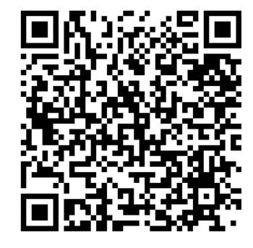

The Frances Clark Center for Keyboard Pedagogy, a not-for-profit educational institution (501c3) located in Kingston, NJ, serves pianists and teachers through its divisions: The National Conference on Keyboard Pedagogy, Piano Magazine, Teacher Education, and the New School for Music Study. www.nsmspiano.org

